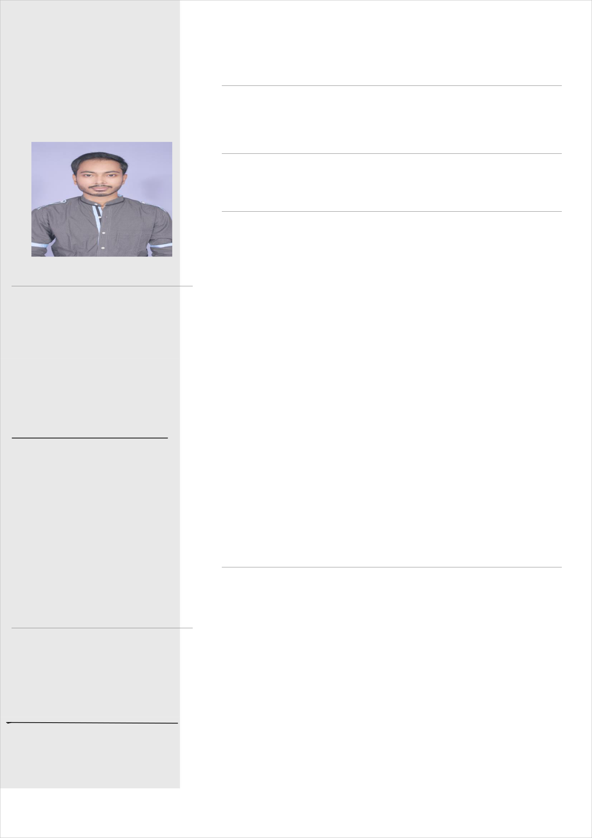 **ASHISH KUMAR**

**CONTACT**

**Address:** Sri Sai Residency**,** Battarahall**i**,Krpuram,Bangalore, Karnataka. 560049

**Phone:**

+91 9430233354,8442880530

**Email:**

[ashishprashar37@gmail.com](mailto:ashishprashar37@gmail.com)

**SKILLS**

Python

django

Flask

PHP

SQL

C#

MS Office

HTML

CSS

JavaScript

**LANGUAGES**

English

Hindi

Bengali

**HOBBIES**

Playing Cricket

Watching Movie

Making Friend

**OBJECTIVE**

To acquire a position in an organization where I can best develop my skills and attain growth.

**EXPREIENCE**

Fresher

**EDUCATION**

**Cambridge Institute of Technology**

2018-2020

MCA

65%

**Techno India**

2015-2018

BCA

67%

**BSCB**

2013-2015

Intermediate

56.4%

**CBSE**

2012-2013

Metric

81.7%

**Project**

|  |  |
| --- | --- |
| **Restaurant Management System** | **2018** |

Web Server - Tomcat v8.5 Server at Localhost Back end – MySQL , Servlet, java

Front end - HTML, CSS, jQuery, Bootstrap, JS .

|  |  |
| --- | --- |
| **Online News Portal** | **2019** |

Front end - HTML, CSS, jQuery, Bootstrap, JS .

Back end – MySQL , PHP

Server- WAMP/XAMPP

